
GWRRA Chapter FL1-A2, established 1982 October 2000
NATIONAL OFFICE Mike & Judy Wright, Executive Director (219) 248-8166
REGION A DIRECTOR Jim & Margie Hodge (228) 875-1764
DISTRICT DIRECTOR Bob & Nancy Shrader (813) 885-7963

CD Gold Line

Bye Bye Love Bugs!!
Well, by the time you read this the love bugs should be gone. September and October starts our fall riding season and the weather has been beautiful. There are a lot of rallies coming up, Biloxi Mississippi, Biketoberfest in Daytona, poker run in Panama City, Sweet Potato Festival in Ocilla, Georgia, and many one day rallies. Take the time to participate in some of these rallies you will be glad you did.

For those of you who missed the September meeting it was a unanimous decision not to have a rally in February 2001 as we could not get the date we needed. We will come up with some other type of fund raisers. If you have any ideas let me know. If you get the urge to ride and we don't have a scheduled ride get on the phone and call some of our members to go with you. Spur of the moment rides are sometimes the best rides.

Well, until we meet again ride safe,

John & Ann
Chapter Director

CHAPTER DIRECTOR
John & Ann Bartlow
(850) 421-1397

ASST. CHAPTER DIR.
Wayne Parmer 926-5371
Rick Stanley (850) 656-6609

SECRETARY/TREAS.
Kate Smith (850) 926-1608

RIDE COORDINATOR
Charles Couch 562-1399

RIDER EDUCATOR
Vacant

NEWSLETTER EDITOR
& AMA COORDINATOR
Karen Krebs (850) 925-0345
krebsk@freenet.tlh.fl.us

PUBLIC RELATIONS
Tom Fisher (850) 386-8493

PHONE COORDINATORS
Charles Couch 562-1399
Sonny Rollo (850) 562-4293
Karen Krebs krebsk@freenet.tlh.fl.us

SUNSHINE
Carolyn Campbell
(850) 997-4901

Positions available: contact John to get involved!

We're on the 'net!
Send in your e-mail address to be
on the Chapter e-mail list!
krebsk@freenet.tlh.fl.us

Where Do You Want to Ride in 2001?
Send your suggestions to Charles Couch!
562-1399
honda@nettally.com

PLEASE
PATRONIZE
OUR
SPONSORS

YOUR AD WOULD LOOK GREAT HERE!
925-0345



Swap Shop
Free to Chapter FL1-A2 members
call 925-0345

FOR SALE: Call Sonny Rollo 562-4293.
1982 Gold Wing, 20,000 miles, damaged in front end collision. No front wheel or fork. Engine, frame, instruments, rear suspension and wheel in good condition. $700 or best offer.
Kuryakyn triple exhaust extensions; used, very good condition for GL1500 $60.
Stop and Go tire patch kit - new $30.
Chrome windshield trim with Kuryakyn lighted bird and bug deflector, installed $65.
Orville Sage custom windshield for GL1500, tinted with large engraved eagle, with engraved wind wings, installed $175.

FOR SALE: Call Marvin Culverson, 539-5366.
1998 1100 Honda Shadow Aero: only 1400 miles, black/garnet, whitewalls, spoke wheels, garage kept, $11,000 - $12,000 value - yours for $7500 or best offer!

FOR SALE: Call Jack Schardine (904) 532-9602
Custom built cargo trailer. Convertible top, carpeted inside, spare tire, 48 quart cooler. $450

FOR SALE: Call Charles Couch (850) 562-1399.
Small HJC FJ8 helmet, candy apple red open face w/ flip shield, $50 (Cost $124.99 on the web).

FOR SALE: Call Curtis Parker 422-0996.
DOWCO Guardian bike cover (G45 - small) - new, never out of the box! $35. GL1500 trunk handle, chrome w/hand insert, $20.

October Birthdays
Jack Schardine 10/2
Kate Smith 10/6
Frank King 10/9
Marilyn Mears 10/14
Dean York 10/14
Pat Gordon 10/17
Bill Webster 10/18
Jennifer Webster 10/18
Ken Van Gordon 10/24
Jerry Langley 10/30

October Anniversaries
Mike Share & Karen Krebs 10/3
Dean & Ann York 10/14


Do you know a member with illness or death in their immediate family? Call Carolyn Campbell, Sunshine Chairperson, 997-4901.

WANT TO REACH OVER 80 MOTORCYCLE ENTHUSIASTS?
Advertise!!
Low rates: only $15.00 for a business card size ad for 3 months! Call the Advertising Department - (850) 925-0345 (ask for Karen) or
e-mail: krebsk@freenet.tlh.fl.us

BUSINESS CARD SIZE ADS
$15.00 for 3 mos./$50 per year
1/4 page $25.00 for 3 months
1/2 Page $35.00 for 3 months
Full Page $50.00 for 3 months
Next Month's Birthdays
Ann York 11/12
Rita Hodsdon 11/30

Next Month's Anniversaries
Ken & Susan Van Gordon 11/6
Wayne & Margaret Parmer 11/12
Cliff & Corinne Mathis 11/27
Rick & Evy Friend

Time to Re-Up
from 1/00 printout

October
Steve & Sheila Carroll
Lauren Waller

November
Andy & Rosemary Anderman
Ken & Mary Lee Rouse

Welcome Back
to Thurman and Wanda Compton; great to have them back!!!

Get the Lead Out Award
Goes to Pat Gordon for Part II of "Wing Ding Trip", and Rita Hodsdon for her article on "Sturgis Bike Week!'

GET THE LEAD OUT AWARD

is waiting for you!
Got an article? Call the editorial office:

(850) 925-0345
or e-mail: krebsk@freenet.tlh.fl.us

Articles may be submitted in WORD '97
or other convertible format.

Wing Ding Trip
Part II
by Pat Gordon

July 6: (continued) What a ride! We rode about 500 miles that day on the Gold Wing, saw some beautiful sights and cold and windy mountains. The wind was so strong on top of mountain that I had to hold onto the helmet visor to keep the wind from blowing under it and pushing my head back. There were snowdrifts in the crevices and a lake was still frozen. We crossed the Yellowstone River many times. Only one view was unpleasant, the remains of a forest fire and blackened tree trunks still standing. At the town of Gardiner we exited the north entrance of the park and returned to Billings at 11:30 pm. The motor home was waiting outside of the campground. The transmission shop employees had returned it for us and didn't find anything wrong and didn't charge for checking it out.
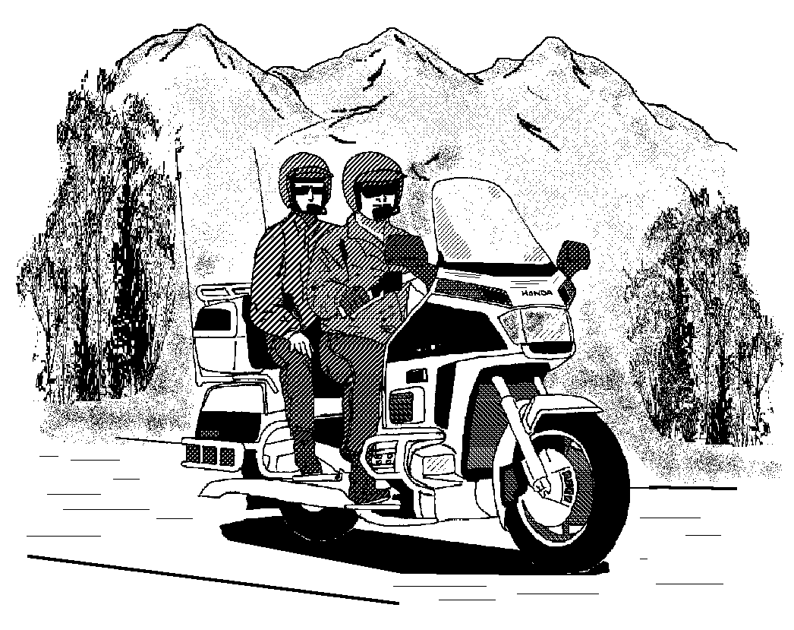
July 7: We went back to the Metra to look for Greg and Carol's trike. George spotted it in the parking lot and we left a note on it that we were looking for them. When we returned to the parking lot after searching the exhibit buildings we found Greg at our bike leaving a note. Carol was doing some last minute shopping; they bought new helmets and a sound system. We left the Metra after making last purchases and loaded up and left at 4:15 pm. We missed a lot of the competition and shows at the Wing Ding; there was so much going on at one time making it impossible to see everything. Last stop at Flying J to empty holding tank in motor home and fill up with gas at $1.60 per gallon. We left Billings at 5:45 to hit a road construction slow down for 30 minutes going south.

The people in Billings were very hospitable, friendly and helpful. It was a good place for the Wing Ding; there are a lot of things to see and do in Billings and the surrounding area. A lot of historical sites and buildings, museums, zoo, art galleries, western outfitters, antique shops and casinos are there. The Billings' theme is "city style with a country smile."
Back on the road in the motor home I have seen seven dead dear on the road so far, a heartbreaking sight as well as a driving hazard. George gassed up the RV in Bozeman Montana for $1.68 per gallon, then took I-90W to Whitehall, then US 85S. We saw a beautiful sunset, low dark clouds reflecting pink and purple. Around each curve and over each hilltop brings a new vista. George spent 10 minutes washing the RV windows for a panoramic view then drove through a flock of bugs that splattered the windshield. So much for a clear window to take pictures through!

We drove west on I-90 to Butte, then 85S business instead of truck route which went straight through downtown Butte at 10:30 pm. The streets were deserted and not too friendly looking. We got lost in town and it was difficult to turn around driving our long rig. We finally got out of town and back on the highway. 85S goes over the Continental Divide. The road is rough and grooved, lots of bouncing in the motor home. We spent the night in a rest stop.
July 8: Left the rest stop at 7:00 am; the weather was cold. We finally got out of the Montana at 9:00 am and crossed into Idaho. We stopped for breakfast at the Family Restaurant at Idaho Falls and left at 11:20 am. Back on I-15S through the Blackfoot and Crow Indian Reservation. Strong winds hitting the side of the motor home and trailer made it difficult to drive in the Teton Mountain range. Another dead dear on side of highway - I have lost count now, seven or eight.

At 1:45 pm we crossed the Utah State line. Now we were looking for a RV repair business to repair the electrical hook up to the trailer that came loose and dragged on the road, melting the connection. We stopped at a tourist information rest stop north of Brigham to find a RV dealer. Sierra RV fixed the connection temporary for $30.00. While we were there a storm hit; the winds were like a hurricane; but it only lasted about 15 minutes. Back on the road again, heavy traffic and construction around Salt Lake City, so we took the by-pass I-215. At 6:30 pm the wind and seas are rough, (it's like being in a boat in choppy water). At Fillmore, Utah George filled up the RV at 7:00 pm, then filled up the water tank; we ran out of water the day before. We had dinner at the Paradise Inn; the service was slow and George couldn't eat his liver dinner. Not exactly like Paradise. George called his Dad, but he wasn't home; he left message that we are in Utah. Road construction again - we stopped at rest stop for the night 11:30 pm.
July 9: We left the rest stop at 8:00 am heading south on I-15 into a dark rain cloud. We drove through St. George, Utah which looked like an all new town, roads and homes. Crossed into Arizona 9:00 am, drove through Virgin Mountains, "incredible" rocks and curves; I turned on the video camera. The road winds through a canyon with solid rock mountains all around. From the rock mountains into the dessert, tumble weed and Joshua cactus. Mountains in the distance all around in every direction. The Moapa Indian Reservation is in the desert; the Indians really got some "choice land."
We drove though Las Vegas, couldn't believe all of the new casinos since my last visit. They are like palaces and each one with a different theme and design. One casino looked like a pyramid, another one like the skyline of New York City. We stopped at the last chance Casino at the Nevada border. George played 21 and I played a slot machine; we only stayed about 25 minutes and left at 1:00 pm. The wind on the desert was strong and hitting us from the side almost blowing the motor home off of the road. We gained one hour there.
We passed Baker, California, Home of Bun Boy and the world's tallest thermometer. It was 101° when we passed. The desert gets depressing after so long, nothing but stone barren mountains, sand and sage brush. I told George that I am sick of the barren mountains and want to see something green! All traffic stopped at California inspection station; the officer asked where we came from and if we had any fruit or cherries with us.

We stopped at Victorville, California and George called an old friend and his wife who met us and we drove with them to lunch at Coco's. We had a nice lunch and they came back with us for a short while to the motor home. The smog from L.A. can be seen here in the distance. George's dad called on the cell phone to find out where we were. He was at a neighbor's party and wanted to be sure he would be home when we arrived.
Still Sunday at 6:00 pm; we are on I-15 South, 50 miles from L.A., lots of wind and traffic. We arrived at 8:00 pm at George's dad's home in Mission Bay, San Diego, CA.
July 10: We visited with Dad; he drove us to Bank America to take care of some business, then to the San Diego Wild Animal Park where we spent the afternoon. The park is very large and we did a lot of walking and taking video and photos. We saw an elephant show and a bird show and took a train ride all around the park. Too much walking and heat for Dad, so we left. On the way back to Mission Bay we stopped for dinner at the Home Town Buffet restaurant near his home. The food was great with a big selection.
July 11: Dad drove us to Old Town (original settlement of San Diego) - lots of quaint shops, restaurants and a Spanish Hacienda. We ate breakfast at O'Hungry's, a Mexican café; it was very good. We shopped and then drove around the neighborhood to see Heritage Park, old Victorian homes that have been refurbished and turned into businesses or shops. Then to "Seaside Shoppes" downtown on the waterfront. Everything was beautiful but very expensive, so we returned to "Old Town" for a late lunch at O'Hungry's again and to pick up a shirt that I forgot to purchase. We returned to Mission Bay and hooked up the trailer in the parking lot so we could leave early next morning. San Diego is beautiful, clean and flowers everywhere. It is my favorite part of California.
July 12: We left San Diego at 8:00 am on I-8 back in the mountains. The elevation is 2,000 and then 4,000 feet, nothing but rock mountains and boulders. At 10:00 am we reached the flat dessert at sea level. From the dessert we drove into farm country in the Imperial Valley, where we ran into a flock of yellow butterflies. We stopped at a truck stop to gas up for $1.82 regular gas and ate lunch at Millie's Kitchen. We left there at 12:30 pm and crossed Arizona state line at Yuma 45 minutes later, where we lost an hour. It is hard to keep track of the time on this trip, so many time changes.

At the border of Arizona on I-8 at 3:15 pm we crossed a border check. The officer was from Gainesville so he let us through easy without checking for Mexicans. We could have carried a lot of them in the trailer and in the motor home. Dust Devils (small whirl winds) can be seen on the dessert in the distance. We stopped at Gila Bend for ice cream at DQ and gas. It was very hot and dry there. I took pictures of the saguaro cactus - some looked like trees. A large portion of Arizona is Indian Reservations. Outside of Tucson we stopped at the first Waffle House in the West and went to K-Mart for more video tape for the camera. At 8:45 pm it is still bright and we were in Apache territory east of Tucson. We stopped again for gas at Benson, AZ. ($1.62) to make sure we didn't run out in the dessert.
The motor home has a panoramic view, almost as good of a view as on the Gold Wing. I have been out west and across the country before but forgot how vast the desert is or how enormous the mountains are. At 12:00 midnight I noticed that we must have crossed over into New Mexico. I didn't see the state line sign, I must have dozed off. It is very windy and hard to control the RV, but George wanted to go on. We stopped at the next rest stop for the night. The winds were high and there was lightning, but no rain.
July 13: We left the rest stop in New Mexico at 7:15 am, back into the dessert. At 10:15 am we crossed the Texas border. El Paso is a huge city and near the Mexican border. Next stop for gas $1.57 regular at Van Horn, Texas. (Gas should be cheaper in Texas.) We took a walk to stretch and get a snack, left there at 2:30 pm. We are back in the desert again and cattle ranches. The wind is strong and a few dust devils are spotted. We ate at Kerryville, Texas Cracker Barrel (good dinner) and left at 9:15 pm. We stopped at the next rest stop for the night at 9:45 pm.
July 14: We left the rest stop at 8:00 am and drove through San Antonio at rush hour. We took the by-pass (410) around the city. No stopping here, very busy. Back on I-10 at 9:00. Next stop Sequin for breakfast at K&G Steak House (good food). At Schulenburg, TX we stopped for gas ($1.55 per gallon) at 11:15 am. We saw the second traffic accident of the trip there. We also passed the "Outdoor Bass Shop," the second one we have seen since our Springfield Missouri trip to Wing Ding. At Katy Mills exit 740 off of I-10 is a large antique center, 40 miles West of Houston. At 12:45 pm we got into Houston traffic. We took the I-610 freeway around Houston north to I-10. Highway 10 is being raised and under construction there.
It's still Friday 7/14 and we are still in Texas (it takes a long time to cross Texas); last stop in Texas for gas $1.45 at Beaumont. The gas pump handle got stuck and gas valve overflowed onto the pavement. We had to wait for the gas station attendant to clean it up before starting the engine. Road construction made it hard to get out of the station. We were glad to leave there at 3:15 pm. We crossed into Louisiana at 3:30 pm, the road has a concrete surface and very bumpy. There was a construction slowdown 24 miles west of Lafayette and we almost rear-ended a semi truck. We lost one hour here due to road construction. At 6:00 pm we stopped to eat at Landry's Seafood House (good food) we left at 7:20 pm. It is a long drive over the bayou and rivers. At Baton Rouge we took the I-12 to by-pass New Orleans. No time to stop this trip. There was a big traffic accident in Baton Rouge west bound. That is only three traffic accidents we have seen on this trip, pretty good. At 9:30 pm we stopped for the day at the Mississippi welcome center rest stop. It is the nicest place we have stopped to park for the night. They have a separate section for RV's and it was very quite and a nice park atmosphere.
July 15: We left the park at 7:50 am on Saturday, our last day of the trip. We stopped in Mississippi for gas and crossed the Alabama state line at 9:15 am. At Foley, Alabama there is another "Lamberts Home of the Throwed Rolls" restaurant like the one we ate at in Branson, Missouri. We crossed the Florida state line at 10:15 am. I-10 is under construction, down to one lane in some areas. At mile markers 53 and 54 there are actual hills in Florida!

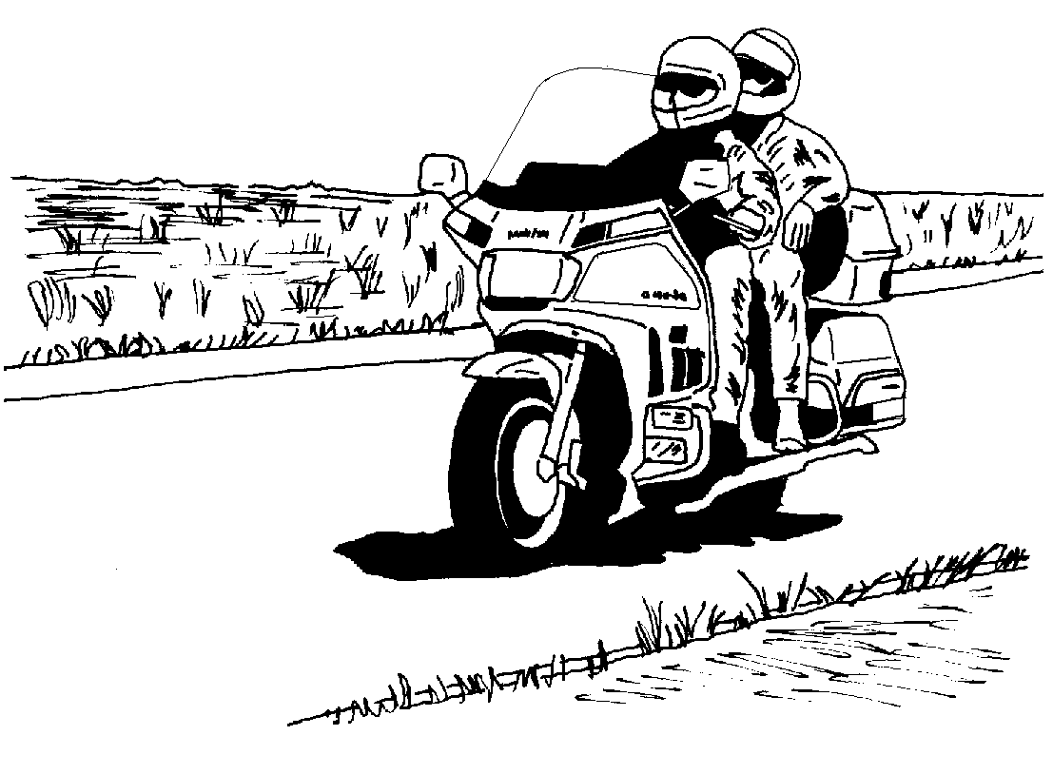

We stopped at McLains Family Steak House in DeFuniak Springs for lunch. It was a great buffet, left at 1:30 pm (back on Eastern time again). Chipley has an antique mall at mile marker 118 on the hill. Last stop of trip at Flying J on highway 90 to dump motor home holding tank. Arrived at home in Havana 3:50 pm.
It was a 6,000 mile trip. Gas prices ranged from a low in Georgia of $1.40 to a high in California and South Dakota of $1.82. Total gas spent on the trip, $1,818.00!!!! George was the pilot, chauffeur, troubleshooter and big spender. Pat was the co-pilot, not so perfect navigator, photographer, chief cook and bottle washer.
It was a good trip - we saw a lot of the country, 20 states, incredible scenery, enough corn to feed the world, fantastic sunsets, met some new friends, and visited some old friends and family. And we renewed the feeling of the vastness and beauty of this country.


LOCAL RALLIES & EVENTS

October 12 Chapter meeting - Western Sizzlin'
6:30 eat, 7:30 meet
Departure Points
#1: Hardees, N. Monroe
#2: Circle K, Hwy. 20 & Capital
Circle
#3: Circle K, Crawfordville
Highway & Capital Circle
#4: Chevron, Highway 98 &
Woodville Highway
#5: CITGO, Hwy. 90 & I-10 east
(cross creek)
#6: Books-A-Million,
Thomasville Road & I-10
#7 I-10 rest stop west of Exit 28
(Capital Circle NW)
October 19 Dinner ride - Boomer's BBQ, Monticello.
Depart #5 at 6:30
October 26 Dinner social - King Buffet, Apalachee
Parkway (formerly Lucy Ho's). Eat at 6:30.
November 9 Chapter meeting - Western Sizzlin'
6:30 eat, 7:30 meet
November 16 Dinner ride - Terry Lynn's (formerly
Country Boy's), Bainbridge. Depart #1 at
6:30 p.m.
November 23 Happy Thanksgiving!
November 30 Dinner social - Don Pablo, Capital Circle NE. Eat at 6:30.
December 3 Toys for Tots parade - Tallahassee

REGIONAL RALLIES & EVENTS

October 12 - 14 Mississippi District Rally - Biloxi
October 19 - 22 Biketoberfest - Daytona
October 27 - 28 Sweet Potato Festival - Ocilla, GA
October 28 FL1-L - Panama City Poker Run
November 11 FL1-J - Jacksonville Poker Run
November 12 FL1-D2 - New Port Richey Poker Run
November 25 FL1-A - Tampa Poker Run
December 2 FL1-W - St. Augustine Poker Run
December 9 FL1-S - Zephyrhills Poker Run
July 3 - 6, 2001 Wing Ding - Greenville, SC
Wear Your Colors

Don't forget to wear your Chapter uniform at other chapter's events! Our
uniform is the red Chapter shirt and black jeans.

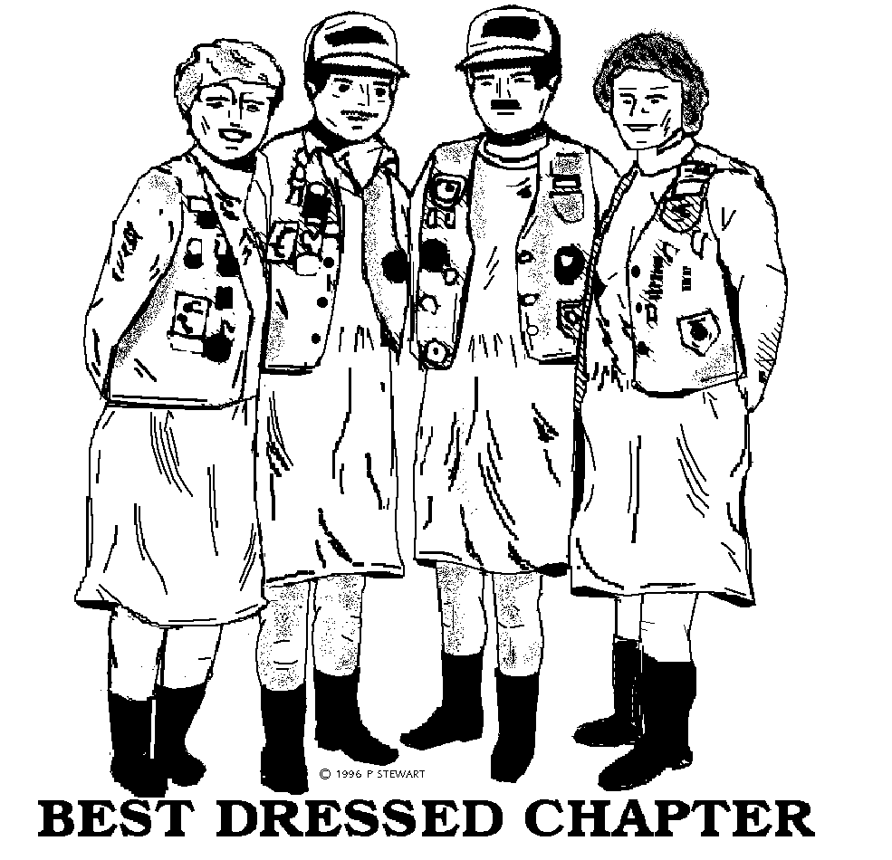

Departure Points
#1: Hardees, N. Monroe
#2: Circle K, Hwy. 20 & Capital Circle
#3: Circle K, Crawfordville Hwy. & Capital Circle
#4: Chevron, Hwy. 98 & Woodville Hwy.
#5: CITGO, Hwy. 90 & I-10 east
#6: Books-A-Million,
Thomasville Road & I-10
#7 River Trace Homes, Woodville Hwy. & Capital Circle SE
#8 I-10 rest stop west of Exit 28 (Capital Circle NW)
NEWSLETTER DEADLINE: 4th THURSDAY
PUBLICATION: 2nd THURSDAY
Please let us know if you no longer want a newsletter -
they cost us $1.02 each!!!

Many flyers available at the meeting from John Bartlow.
Wear Your Colors

Don't forget to wear your Chapter uniform at other chapter's events! Our uniform is the red Chapter shirt and black jeans.
Call Charles Couch or the Telephone Coordinators for
more information on scheduled and unscheduled rides!

