MOTORCYCLE
SHOW
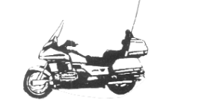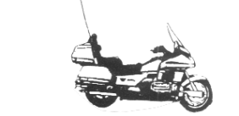
Tallahassee Mall
Saturday, August 4, 2001
10:00 am to 9:00 pm

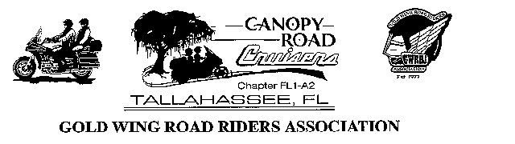

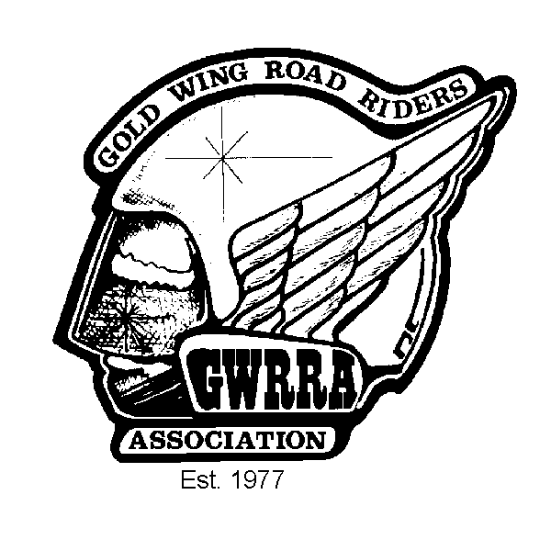

Sponsored by
Canopy Road Cruisers

The Tallahassee Chapter of the
Gold Wing Road Riders

GWRRA Chapter FL1-A2, established 1982 May 2001
NATIONAL OFFICE Mike & Judy Wright, Executive Director (219) 248-8166
REGION A DIRECTOR Jim & Margie Hodge (228) 875-1764
DISTRICT DIRECTOR Bob & Nancy Shrader (813) 885-7963

CD Gold Line

That's A Lot Of Tires To Kick!
T he recent kick tire gathering in Andalusia, Alabama was indeed encouraging. Nine of our Chapter members journeyed close to 175 miles to join in. Present were about 450 bikes from different panhandle and Alabama GWRRA chapters and the Southern Cruisers from Alabama. It was about the same size as Tallahassee's Toys for Tots ride. I was delighted to see so many people coming in and enjoying riding their bikes!

The chapter directors will be working to hold other kick tire events and the latest will be held in Dothan on April 28th. Perhaps we can pull together a kick tire event at Julie Mae's or in Apalachicola in the near future.

Linda and I recently attended the District Rally in Tampa. It was well attended with 1241 registered. The vendors numbered around 50 and had the usual offerings. Tom Fisher also attended from our Chapter. The District Rally is scheduled to be held at the same spot in Tampa next year.

I'd like to thank everyone who attended our campout/picnic at Pat Thomas Park. John Ferrell did a wonderful job on the BBQ chicken and Marvin Culverson and Wayne Parmer again did a super job in getting our hot dog lunch prepared. Thanks again to everyone who helped, brought food, drink and items for the meals and the day's success!

As a final note, be reminded that Wing Ding is coming to Greenville, SC July 3 - 6. I hope many of you can go and experience the grandeur of this event. It is a rally that every
continued on page 2

SENIOR CHAPTER DIRECTOR
Charles & Linda Couch
(850) 562-1399
honda@nettally.com

ASST. CHAPTER DIR.
Hugh Waller 562-4542
mjenwal@aol.com

SECRETARY/TREAS.
Kate Smith (850) 926-1608
tiffanyrose@townbeacon.com

RIDE COORDINATOR
Charles Couch 562-1399
honda@nettally.com

RIDER EDUCATOR
Tom Fisher (850) 386-8493
tfisher@nettally.com

NEWSLETTER EDITOR
& AMA COORDINATOR
Karen Krebs (850) 925-0345
krebsk@freenet.tlh.fl.us

PUBLIC RELATIONS
Mike Share (850) 925-0656
mjds@usa.net

PHONE COORDINATORS
Ann Bartlow (850) 421-1397
Sonny Rollo (850) 562-4293
Karen Krebs krebsk@freenet.tlh.fl.us

SUNSHINE
Carolyn Campbell
(850) 997-4901

Positions available: contact Charles to get involved!

CD Gold Line (continued from page one)
Winger should try and attend and experience. I predict a lot of new GL1800 after-market products will debut there for the first time. Hope you can make it!

Ride Safe,

Charles
Senior Chapter Director

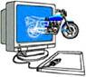

We're on the 'net!
Send in your e-mail address to be
on the Chapter e-mail list!
krebsk@freenet.tlh.fl.us
Swap Shop
Free to Chapter FL1-A2 members
call 925-0345
FOR SALE: Call Steve Carroll 907-0776 evenings or 942-9650 x3004 days.
Markland Black/Charcoal backrest ($179 retail) $95.00
FOR SALE: Call Charles Couch 562-1399.
One piece insulated riding suit, size Large (short). Like new, $50.
Small HJC FJ8 helmet, candy apple red open face w/ flip shield, $50 (Cost $124.99 on the web).
FOR SALE: Call Sonny Rollo 562-4293.
1982 Gold Wing, 20,000 miles, damaged in front end collision. No front wheel or fork. Engine, frame, instruments, rear suspension and wheel in good condition. $700 or best offer.
Kuryakyn triple exhaust extensions; used, very good condition for GL1500 $60.
Stop and Go tire patch kit - new $30.
Chrome windshield trim with Kuryakyn lighted bird and bug deflector, installed $65.
Orville Sage custom windshield for GL1500, tinted with large engraved eagle, with engraved wind wings, installed $175.
FOR SALE: Call Curtis Parker (229) 377-3260
DOWCO Guardian bike cover (G45 - small) - new, never out of the box! $35.
GL1500 trunk handle, chrome w/hand insert, $20.



May Birthdays
Ann Langley 5/3
Lauren Waller 5/5
Charles Couch 5/9
John Ferrell 5/10
B.J. Allen 5/12
Virginia Hart 5/28

May Anniversaries
Richard Pulliam & Fonda Watts 5/17
Rob & Marisol Nielsen 5/20
Jack & Mercy Henderson 5/22
Sonny & Ann Rollo 5/30

Time to Re-Up
from 1/5/01 printout

May
Marvin & Jo-Nell Culverson
Jerry & Ann Langley

June
Ben & Virginia Hart
Cliff & Corinne Mathis
Bud & Kate Smith


Do you know a member with illness or death in their immediate family? Call Carolyn Campbell, Sunshine Chairperson, 997-4901.

WANT TO REACH OVER 80 MOTORCYCLE ENTHUSIASTS?
Advertise!!
Low rates: only $15.00 for a business card size ad for 3 months! Call the Advertising Department - (850) 925-0345 (ask for Karen) or
e-mail: krebsk@freenet.tlh.fl.us

BUSINESS CARD SIZE ADS
$15.00 for 3 mos./$50 per year
1/4 page $25.00 for 3 months
1/2 Page $35.00 for 3 months
Full Page $50.00 for 3 months
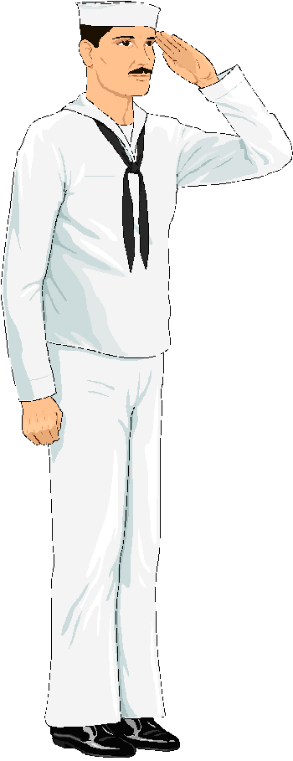Next Month's Birthdays
Brenda Dekle 6/3
Rob Nielsen 6/10
Linda Henley 6/17
Sim Dekle 6/19
John Bartlow 6/24
George McKee 6/29

Next Month's Anniversaries
Bob & Ann Lumsden 6/3
John & Ann Bartlow 6/9
Buck & Carol Harris 6/25

Kudos
to John Ferrell for the delicious beer chicken, and to everyone else who helped make the Chapter camp out a success!!

Welcome
to Rob & Marisol Nielsen, friends of John Ferrell - we hope to see more of them!!!!

Get the Lead Out Award
goes to our resident journalist, Tom Fisher for his report on the Florida District Rally! Come on, someone give him a break and write an article - Tom is definitely overworked and underpaid!!

GET THE LEAD OUT AWARD

is waiting for you!
Got an article? Call the editorial office:

(850) 925-0345
or e-mail: krebsk@freenet.tlh.fl.us

Articles may be submitted in WORD '97
or other convertible format.

by Hugh Waller

Why I Ride !

It's too easy to say to a non-rider, "you have to ride to understand", but I believe trying to explain it may actually renew your own reason for riding. The first things that come to my mind are freedom, adventure, and therapy for the mind, body, and spirit. There's nothing like a Saturday morning breakfast ride with a group of friends after a hectic week at work.

After a three year absence from riding, with the exception of a couple of rides on borrowed bikes (thanks Charles and Marvin), my excitement for riding has been renewed by several events. The introduction of the new Gold Wing with it's revamped styling, handling, and power has me chomping at the bit! I still love the 1500, even the 1200, actually anything with two wheels and a motor.

My youngest brother has decided to get back into riding also. He rode a Honda CB900F in his early twenties while in the Navy stationed in California. Now in his early thirties, still single, and a successful CPA, he can now afford a new bike. I'm looking forward to he and I going to some rallies and traveling some of the beautiful roads such as the Blue Ridge Parkway together. I'm looking forward to this because I missed out on watching him grow up. When I left home to go to college, he was only six years old. After college, then spending a few years overseas in the military, my brother had become a young adult. Our shared passion for motorcycle riding will give us time to catch up.

Losing someone in your family usually changes your perspective on life. It makes you realize that life really is short! After losing my mother last August (only 65) and my brother-in-law just three weeks ago, who was only 42, I feel compelled to enjoy life a little more. For me that means spending quality time with family and riding with friends.

Laura Brengelman, editor of "Motorcycle Tour and Cruiser", stated in a recent issue, "I ride to see what there is to be seen and to discover what's around the next bend. An insatiable tourist, I never get enough of drinking in the scenery." She goes on to say, "I realized that another reason I ride is that it brings the world closer, makes it more immediate. Being so utterly out in the world- not enclosed in a car- you're more likely to stop and explore. To connect with what's out there and be affected by it." I think her words are so true, so get out there and ride!

Hugh

_{PR Corner}
by Mike Share
Public Relations Coordinator

Oh, My… Decisions, Decisions.…

Do I write my article or clean the scoot for the Bike Show August 4th?

I'm done….

Mike

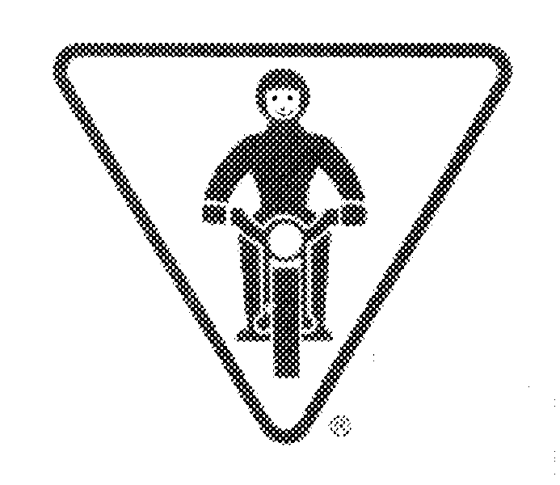
Safety Corner
by Tom Fisher
Rider Educator

SIPDE – Surviving on A Motorcycle

Last week I had the occasion to fly to California and back to Miami on business. It was a long trip, particularly when taking the “red-eye” eastward. It is funny how I can go to sleep before the doors are shut when I am taking shorter trips, but on the “red eye” I cannot sleep at all.

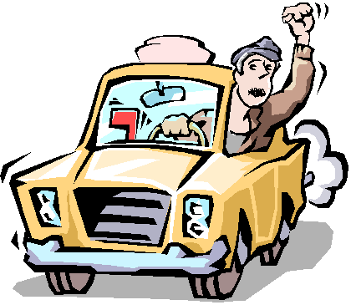Anyway, when I got to Miami, I had to take a cab over to Coral Gables where my meeting was to be held. It was not a long trip, but it certainly was an education in how NOT to drive a cab. All the way to the hotel, I was praying we would arrive in one piece.

I was reminded that motorcycle safety depends, in part, on the acronym, “SIPDE.” The letters stand for:

S – Scan
I – Identify
P – Predict
D – Decide
E – Execute

The cab driver obviously did not practice SIPDE as we careened down the street. He dialed numbers on his cell phone and talked to various people while switching lanes, left, right, left. No signals other than to honk his horn. He turned left in front of on-coming traffic without any turn signals. He ran the cab between lanes and honked for people to move over.

Most importantly, he did not look ahead and predict what was going to happen. Repeatedly, I would watch the string of cars in front of us as their brake lights flashed. It was obvious when a truck several vehicles ahead was completely stopped, yet this fearless cabby was oblivious to the lights. He would not apply his brakes until the last second before a crash, and every braking maneuver was accompanied by loud squeals from the rear wheel brakes. He needed new brake pads badly.

If he had been trained in SIPDE, he would have done the following:

- Scan – look ahead search for possible hazards
- Identify – identify potential conflicts with your bike – cars, animals, stationary objects, etc.
- Predict – Anticipate what the hazard might do.
- Decide – Make a decision as to how to handle the situation.
- Execute – Maneuver the motorcycle in a smooth and controlled manner to evade the problem.

These steps to increased motorcycle safety should not be ignored. Experience makes us overly confident, and it takes only a split second of inattentiveness to become a statistic.

Remember our GWRRA slogan, “Safety Is for Life!”

Tom

Florida District Rally

By Tom Fisher

I was all set to leave Thursday afternoon and get at least part way to Tampa for the Florida District Rally. The weather looked pretty tolerable, and I was anxious to leave. Whoops! A special work meeting was called for 2:15 p.m. I could still make it out of town if the meeting would be mercifully short. At 2:15, the meeting was delayed until 2:45. At 2:45, it was canceled. Well, there went the early start.

I got up Friday morning to threatening skies but was determined to leave anyway. By 8 a.m., I was on the way down U.S. 27/98 toward Perry. The clouds played chase with me all the way down, but I arrived at the rally site in mid-afternoon with no problems.

My main objective was to enroll in the CPR and First Aid classes since I am the Chapter Educator. Unfortunately, I missed the CPR class but was able to sign up for the other. I spent the remainder of the afternoon doing a quick check of the vendors and then headed for the Cracker Barrel for dinner.

On Saturday, the First Aid class was to begin at 8 a.m., so I was there early as were several other participants. There were not many people in attendance, which is too bad because it was a good overview of First Aid principles. We had an instructor who worked for the Sheriff’s Department, and he was armed with a good (and graphic!) video. I am sure my exposure to the content was not enough to qualify me for work as a medic, but it was certainly good enough to be of benefit. If you have not taken the course, why don’t you consider it? No tests. No homework. You do not have to volunteer to be the class “dummy” when they talk about drowning.
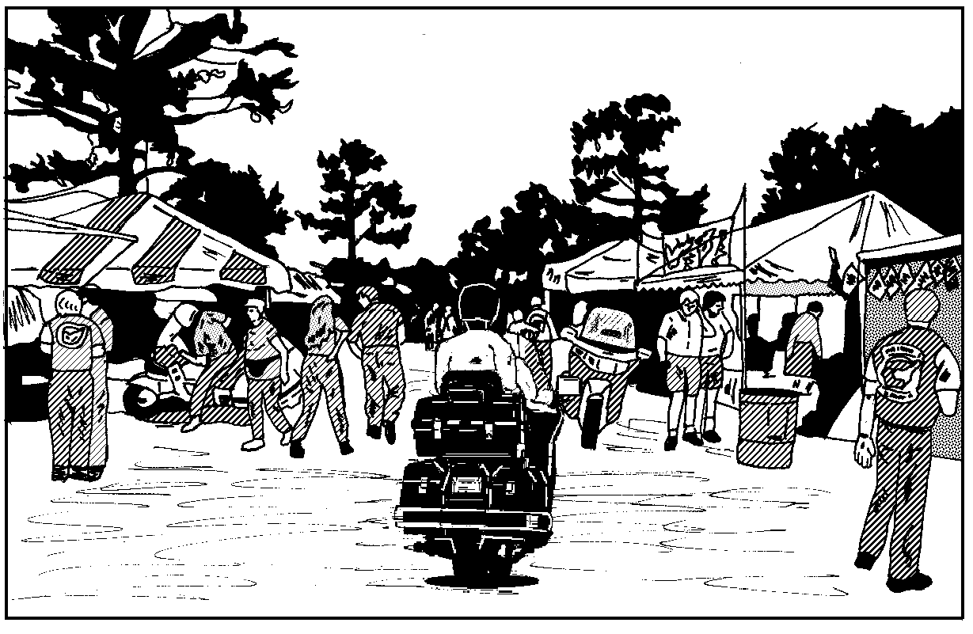
I fooled around in the afternoon and watched the bike judging contest. There were some really nice Honda 1100’s and one Honda 1000. Of course, it was necessary to take another turn around the vendor arena and spend some money. At 3:00 p.m., the schedule called for a demonstration by the Daytona Drill Team, but a quick thunderstorm put an end to that.

The closing ceremony was of the usual format. Lots of people in attendance, lots of “thank you’s,” a speech or two, and the real business of drawing for the new bike. It was won by a lady rider, and she was thrilled to death by her good luck. There were 1,241 people registered for the rally, but I only saw one other person from Tallahassee – our esteemed Chapter Director, Charlie Couch, and his wife. The rider coming the longest distance was from Colorado. The longest distance 2-up couple was from New York.

Sunday morning, I was on my way by 9:00 a.m. and headed north on I-75. The weather was wonderful for the first three hours but then got very windy for the rest of the day. I got tired of riding the slab and turned off at High Springs to follow US 41 to US 90 through Life Oak, Madison, and Monticello with the road pretty much to myself.

Madison is a pleasant little town with some history to it. It was founded in 1838, and the town has several very old homes and other buildings of interest. A local cemetery contains the graves of several unidentified Confederate soldiers who died as a result of the battle at Olustee, Florida.

Madison has a monument recognizing one of its native sons, Colin Kelly. Legend has it that Kelly was awarded the Medal of Honor in WW-II, but this is not quite correct. He was flying a bomber out of the Philippines just after the attack on Pearl Harbor and he decided to attack an enemy cruiser as a target of opportunity. After the bombing run, his plane was shot down by fighters, and he went down with the plane. Luckily, some of the crew hit the silk and survived. Kelly was recommended for the Medal of Honor but actually received the Distinguished Service Cross.

The road from Madison was landscaped by the State of Florida, although many of the bushes seem to have disappeared in the section toward Monticello. After Monticello, there are many more trees and shrubs. This landscaping work began in about 1932 as an effort to provide employment opportunities as well as to beautify the road to Tallahassee. Mr. Fred A. Mahan owned a very large nursery in Monticello at the time, and he donated some 35,000 trees and shrubs for the effort. It surely would be nice if someone would take the initiative and rejuvenate the landscaping along the entire route.

I did not see any accidents on my trip, thankfully. I tried to observe unsafe practices by any bikers I encountered, and, by and large, the people at the rally were being polite, careful, and safe. I did see one or two people riding in Bermuda shorts, tank tops, and tennis shoes. The most stunning display of unsafe behavior came from a young man on a crotch rocket who obviously was not a member of GWRRA! As I was returning to the motel Saturday evening for dinner, this fellow took off from the stop light and put his bike on its rear wheel for a distance of about a half block even though it was twilight and the road was wet. He must have had the bike elevated at least 45 degrees. As he roared past me going in the other direction, he deliberately looked at me as if to say, “My bike’s hotter than your bike! Nah, nah, nah!!” As I changed stations on my stereo and leaned back on my soft road sofa, I wished him good luck. He will need it!

In summary, it was a good rally and I learned some useful stuff at the First Aid class. As other rallies come our way, remember to ride safe because,

“Safety Is for Life!”

Don't forget to sign up your
co-rider!


Editor's Corner
by Karen E. Krebs

Thanks, Florida Motorsports!

If you weren't at Florida Motorsports' open house April 7th, you missed it! Kent and Deanna Johnson and the FMS gang put on a great event with demo rides, bike show, live remote radio broadcast (99.9 FM), free soft drinks, etc.!

Mike and I attempted to uphold the reputation of the Gold Wing Restaurant Raiders and locate the F-O-O-D. Wouldn't you know Cliff beat us to it, enjoying the great spread of hot dogs, hamburgers, Guthrie's chicken, pizza, potato salad, etc. George W. also pulled up on his 1800 with a sharp new pin stripe job!

Many Tallahassee riders of all sorts enjoyed the hospitality, rode the Triumphs and Ducatis, and kicked tires. And I didn't miss an opportunity to show off my new Touring Ace!! Afterwards, Mike and I cruised a few hundred miles in south Georgia.

Saaaaaaay, has anyone seen Spring???



May Is Motorcycle Awareness Month

States including Florida, Georgia, Indiana, Iowa, Massachusetts, Michigan, Missouri, Nevada, New Hampshire, New York, Ohio, Oregon, Pennsylvania, South Carolina, South Dakota, Texas, Utah, Washington and Wyoming have all had their governors proclaim the month of May as Motorcycle Awareness and You month. Congratulations to the various state motorcycle rights organizations and motorcycling activists for their work in getting this consequential affair performed again this year and for helping protect motorcyclists on our nations roadways.

NEWSLETTER DEADLINE: 4th THURSDAY
PUBLICATION: 2nd THURSDAY
Please let us know if you no longer want
a newsletter - they cost us $1.34 each!!!

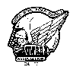
LOCAL RALLIES & EVENTS

Departure Points
#1: Hardees, N. Monroe
#2: Circle K, Hwy. 20 & Capital Circle
#3: Circle K, Crawfordville Hwy. & Capital Circle
#4: Chevron, Hwy. 98 & Woodville Hwy.
#5: CITGO, Hwy. 90 & I-10 east
#6: Books-A-Million,
Thomasville Road & I-10
#7 River Trace Homes, Woodville Hwy. & Capital Circle SE
#8 I-10 rest stop west of Exit 28 (Capital Circle NW)
May 10 Chapter meeting - Western Sizzlin' - 6:30 eat, 7:30 meet.
May 12 Gainesville Rally. Depart #5 at 8:00 a.m.
May 17 Dinner ride - Apalachee Rest., Bristol. Depart #2 at 6:30.
Departure Points
#1: Hardees, N. Monroe
#2: Circle K, Highway 20 &
Capital Circle
#3: Circle K, Crawfordville
Highway & Capital Circle
#4: Chevron, Highway 98 &
Woodville Highway
#5: CITGO, Hwy. 90 & I-10 east
(cross creek)
#6: NEW Publix, Thomasville &
Bradfordville Roads
#7 I-10 rest stop west of Exit 28
(Capital Circle NW)
May 24 Dinner social- King Buffet, Apalachee Pkwy. Eat at 6:30.
June 14 Chapter meeting - Western Sizzlin' - 6:30 eat, 7:30 meet.
June 21 Dinner ride - Worley's, Cairo. Depart #1 at 6:30 pm.
June 28 Dinner social - Mom & Dad's, Apalachee Pkwy. east.
Eat at 6:30 pm.
July 12 Chapter meeting - Western Sizzlin' - 6:30 eat, 7:30 meet.
July 19 Dinner ride - Posey's, Panacea. Depart #3 at 6:30 pm.
July 26 Dinner social - Marie Livingston's, Apalachee Pkwy.
Eat at 6:30 pm.
August 4 Chapter Bike Show - Tallahassee Mall
August 9 Chapter meeting - Western Sizzlin' - 6:30 eat, 7:30 meet.
August 16 Dinner ride-Lunker Lodge, Lake Seminole. Depart #1 6:30
August 23 Dinner social-Don Pablo's, Capital Circle NE. Eat at 6:30
September 29 Chapter Camp out - Holiday RV Park, Panacea.
Camping reservations - 984-5757.
The Oaks Motel 984-5370.
February 16, 2002 Chapter rally

REGIONAL RALLIES & EVENTS

May 12 FL1-Y - Gainesville
May 26 FL1-F2- Ocala
June 2 AL-G - Samson
June 4 - 9 Americade - Lake George, NY
June 14 - 16 Georgia Wing Fling - Hiawassee
June 20 - 23 Honda Hoot - Knoxville, TN
July 3 - 6 Wing Ding - Greenville, SC
July 26 - 28 Honda Homecoming - Marysville, OH
July 28 FL1-D - Pensacola
Wear Your Colors

Don't forget to wear your Chapter uniform at other chapter's events! Our
uniform is the red Chapter shirt and black jeans.
Sept 6-8 Region "A" Rally - Helen GA
September 20-22 NC District Rally - Fletcher, NC
October 6 FL1-L - Panama City
October 11-13 Mississippi District Rally, Biloxi
October 13 FL1-L2 - Bike Show, Lutz
Departure Points
#1: Hardees, N. Monroe
#2: Circle K, Hwy. 20 & Capital Circle
#3: Circle K, Crawfordville Hwy. & Capital Circle
#4: Chevron, Hwy. 98 & Woodville Hwy.
#5: CITGO, Hwy. 90 & I-10 east
#6: Books-A-Million,
Thomasville Road & I-10
#7 River Trace Homes, Woodville Hwy. & Capital Circle SE
#8 I-10 rest stop west of Exit 28 (Capital Circle NW)
October 18-21 Biketoberfest& Drill Team - Daytona
October 26-27 Sweet Potato Festival - Ocilla, GA
November 3 FL1-J - Jacksonville
November 11 FL1-D2 - Hudson
November 24 FL1-A - Tampa
December 8 FL1-S - Zephyrhills

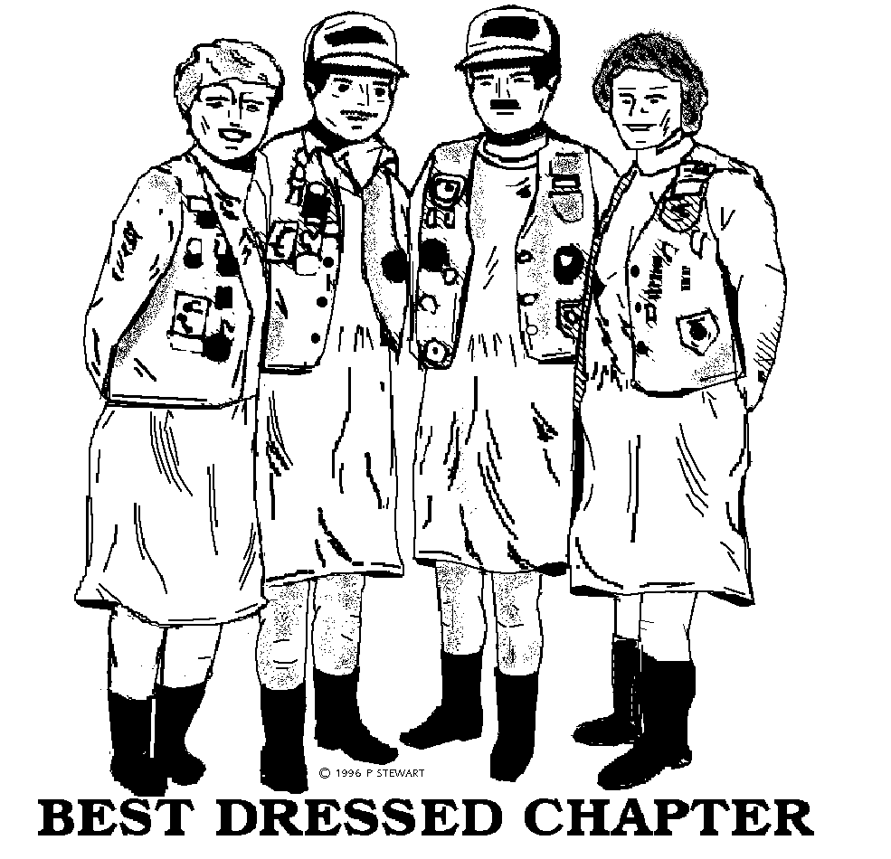
Many flyers available at the meeting from Charles Couch or Hugh Waller. Call Charles or the Telephone Coordinators for more information on scheduled and unscheduled rides!
Wear Your Colors

Don't forget to wear your Chapter uniform at other chapter's events! Our uniform is the red Chapter shirt and black jeans.

