
GWRRA Chapter FL1-A2, established 1982 February 2001
NATIONAL OFFICE Mike & Judy Wright, Executive Director (219) 248-8166
REGION A DIRECTOR Jim & Margie Hodge (228) 875-1764
DISTRICT DIRECTOR Bob & Nancy Shrader (813) 885-7963

CD Gold Line

Ready To Ride?
T he open, well attended staff planning session on January 4th proved to be quite fruitful as we set many dates in regard to rides, camp outs, events and meetings. It appears that we'll have a full agenda of fun activities to select from. I hope as many of you as possible can participate in as many of these events as time allows.

Mike Share will be working with us to organize another successful bike show on August 4th. Hugh Waller has been placed in charge of our Chapter rally, which will be held on February 16, 2002. He will be needing your help and involvement to make it successful. Tom Fisher will be getting our Chapter back into the safety business as our Chapter Rider Educator. Their efforts, along with our other staff and Chapter members, will give us many quality activities during 2001.

As always, chapters thrive when its participants are actively involved. Everyone can help in some way, so please consider volunteering when time allows. Just remember, what you get out of an organization depends greatly on what you put into it. We now have a planned calendar of events just waiting for some good weather and members ready to ride and enjoy each others company. Let's go for it!

Ride Safe,

Charles
Senior Chapter Director

SR. CHAPTER DIRECTOR
Charles & Linda Couch
(850) 562-1399
honda@nettally.com

ASST. CHAPTER DIR.
Hugh Waller 562-4542
mjenwal@aol.com

SECRETARY/TREAS.
Kate Smith (850) 926-1608
tiffanyrose@townbeacon.com

RIDE COORDINATOR
Charles Couch 562-1399
honda@nettally.com

RIDER EDUCATOR
Tom Fisher (850) 386-8493
tfisher@nettally.com

NEWSLETTER EDITOR
& AMA COORDINATOR
Karen Krebs (850) 925-0345
krebsk@freenet.tlh.fl.us

PUBLIC RELATIONS
Mike Share (850) 925-0656
mjds@usa.net

PHONE COORDINATORS
Ann Bartlow (850) 421-1397
Sonny Rollo (850) 562-4293
Karen Krebs krebsk@freenet.tlh.fl.us

SUNSHINE
Carolyn Campbell
(850) 997-4901

Positions available: contact Charles to get involved!



We're on the 'net!

Send in your e-mail address to be
on the Chapter e-mail list!

krebsk@freenet.tlh.fl.us

PLEASE
PATRONIZE
OUR
SPONSORS

YOUR AD WOULD LOOK GREAT HERE!
925-0345

Greetings from Gary & Jo Ann Johns

Many of you have done business with us in the past under First Coast Accessories, Biker’s Dream, Cycle Dreams, and latest, Big Bike Superstore. As of November 2000, we are no longer associated with any of the above.

Starting the new year, look for us under our new banner, Gary & Jo Ann’s Light House. The name says it all...we are back in business for ourselves and doing what we do best, bringing new and exciting lighting products for your motorcycle.

Check out our new L.E.D. lights. They are shockproof, waterproof, low heat output, and come with a three year replacement warranty (labor not included in warranty). All of our installations work is still guaranteed for one full year. Expert electrical wiring and troubleshooting...still a specialty.

We are running a Florida Month special, starting with Bike Week...a six disk Jensen CD Player installed for $329.95 (plus tax). If you pre-order before Bike Week or the Florida District Rally the price will be $299.95 plus tax (GL1200&1500 only).

Gary & Jo Ann’s Light House
11934 Caney Lane
Jacksonville, FL 32218
(904) 751-4378 Fax: (904) 751-4849 Cell: (904) 607-2994
e-mail: jojohns@hitter.net

February Birthdays
Carolyn Campbell 2/3
Karen Krebs 2/3
Durell Daniels 2/8
Curtis Parker 2/11
Rosemary Anderman 2/12
Hugh Waller 2/12
Mary Ann McKee 2/16
Margaret Parmer 2/22
Gary Allen 2/27

February Anniversaries
Bud & Kate Smith 2/14

Do you know a member with illness or death in their immediate family? Call Carolyn Campbell, Sunshine Chairperson, 997-4901.

WANT TO REACH OVER 80 MOTORCYCLE ENTHUSIASTS?
Advertise!!
Low rates: only $15.00 for a business card size ad for 3 months! Call the Advertising Department - (850) 925-0345 (ask for Karen) or
e-mail: krebsk@freenet.tlh.fl.us

BUSINESS CARD SIZE ADS
$15.00 for 3 mos./$50 per year
1/4 page $25.00 for 3 months
1/2 Page $35.00 for 3 months
Full Page $50.00 for 3 months
Next Month's Birthdays
Andy Anderman 3/3
Marvin Culverson 3/3
Jo Nell Culverson 3/5
Mary Lee Rouse 3/5
Ann Bartlow 3/6
Carol Ergenbright 3/6
Ann Lumsden 3/8
Faye King 3/13
Fonda Watts 3/17
Wayne Parmer 3/24

Next Month's Anniversaries
Andy & Rosemary Anderman 3/22

"New Bike" Club
The latest member is our Assistant Chapter Director, Hugh Waller, who has a new GL 1800 on order!!! Hugh will have to wait until May to be back on two wheels!

Time to Re-Up
from 1/5/01 printout

February
Ray Henley

March
John & Ann Bartlow

GET THE LEAD OUT AWARD

is waiting for you!
Got an article? Call the editorial office:

(850) 925-0345
or e-mail: krebsk@freenet.tlh.fl.us

Articles may be submitted in WORD '97
or other convertible format.

Editor's Corner
by Karen E. Krebs

What's Your Favorite Moto-URL?

Members have sent in their favorite motorcycle web sites, including the following:

Subject | URL http://www. (unless otherwise noted)
GWRRA | gwrra.org/
GWRRA Region A | gwrra-regiona.org/
GWRRA Florida District | http://members.spree.com/sports/fldistrict/
All Honda models | motorsports-network.com/ HONDA/index.htm
Americade | tourexpo.com
American Honda | hondamotorcycle.com/index.html
American Motorcyclist Assn. | ama-cycle.org/
bike and product information | motorcycleworld.com
bike information and marketplace | riderworld.com
classic cycle trader | walnecks.com/
Clymer, Haynes or OEM repair manuals | repairmanual.com
Cycle Trader | cycletrader.com/
Daytona Bike Week 2001 | http://208.55.176.135/bwhome.html
Daytona Beach | daytonabeach.com/
Deal's Gap | dealsgap.com
Drill Sgt. Joe's Maintenance Page | http://bongo.www8.50megs.com/maintenance.htm
Gainesville Raceway | gainesvilleraceway.com
Info. on all Gold Wing models | dallas.net/~jsides/gwdisc.html
Goldwingers | goldwingers.com/
The Helmet Shop | helmetshop.com
Honda Rider's Club | hondahoot.com/
Honda Hoot | hondahoot.com/index.html
internet communication network | inbradio.com
loads of links! | moto-directory.com/
Master Strategy Group - safety info. | msgroup.org/TIPS.asp
Motorcycle Consumer News | mcnews.com/
Motorcycle Safety Foundation | http://msf-usa.org/pages/MAIN1.html
National Park Service | nps.gov/
North End Cycle Salvage | necycle.com
Rider Magazine | motorcyclereport.com
Sturgis Rally | sturgis-rally.com
world's best bike roads | http:/62west.net/bikers//roads.html

Know any other good M/C sites, send them in! krebsk@freenet.tlh.fl.us

NEWSLETTER DEADLINE: 4th THURSDAY
PUBLICATION: 2nd THURSDAY
Please let us know if you no longer want a newsletter - they cost us $1.34 each!!!

Safety Corner
by Tom Fisher
Rider Educator

Experienced Rider Course Offered May 26th

Information was recently received from Don Blake, Chapter Educator FL-1D, about an Experienced Rider Course to be offered in the Pensacola area on May 26, 2001. This seems like a long time in the future, but it does take time to make all of the arrangements. The course will require 8 hours of work.

A maximum of 12 bikes will be permitted on the range, so registration will be a first come, first served. Anyone who wants to take the course should send a $35.00 check as soon as possible to FLORIDA RIDER EDUCATION and mail it to:

Don Blake
8195 Lode Star Ave.
Pensacola, Fla.

Sonny
The checks will be held, and when you complete the course the check will be returned to you. If you do not show up, the check will be deposited to the Rider Education Program.

To qualify for the free E.R.C. you must meet the following conditions:

- Be a valid GWRRA Member and enrolled in the Rider Ed Program.
- Checks are only a deposit, they will be returned upon completion of the course.
- All participants must wear proper riding attire (helmet, eye protection, gloves,(not fingerless) long sleeve shirt and pants and over the ankle shoes.)
- Advise which riders will be 2-up.

At the end of the course, riders will receive MSF Completion Cards and co-riders will receive co-rider completion cards. These are the procedures set forth by the Florida District Rider Education Program.
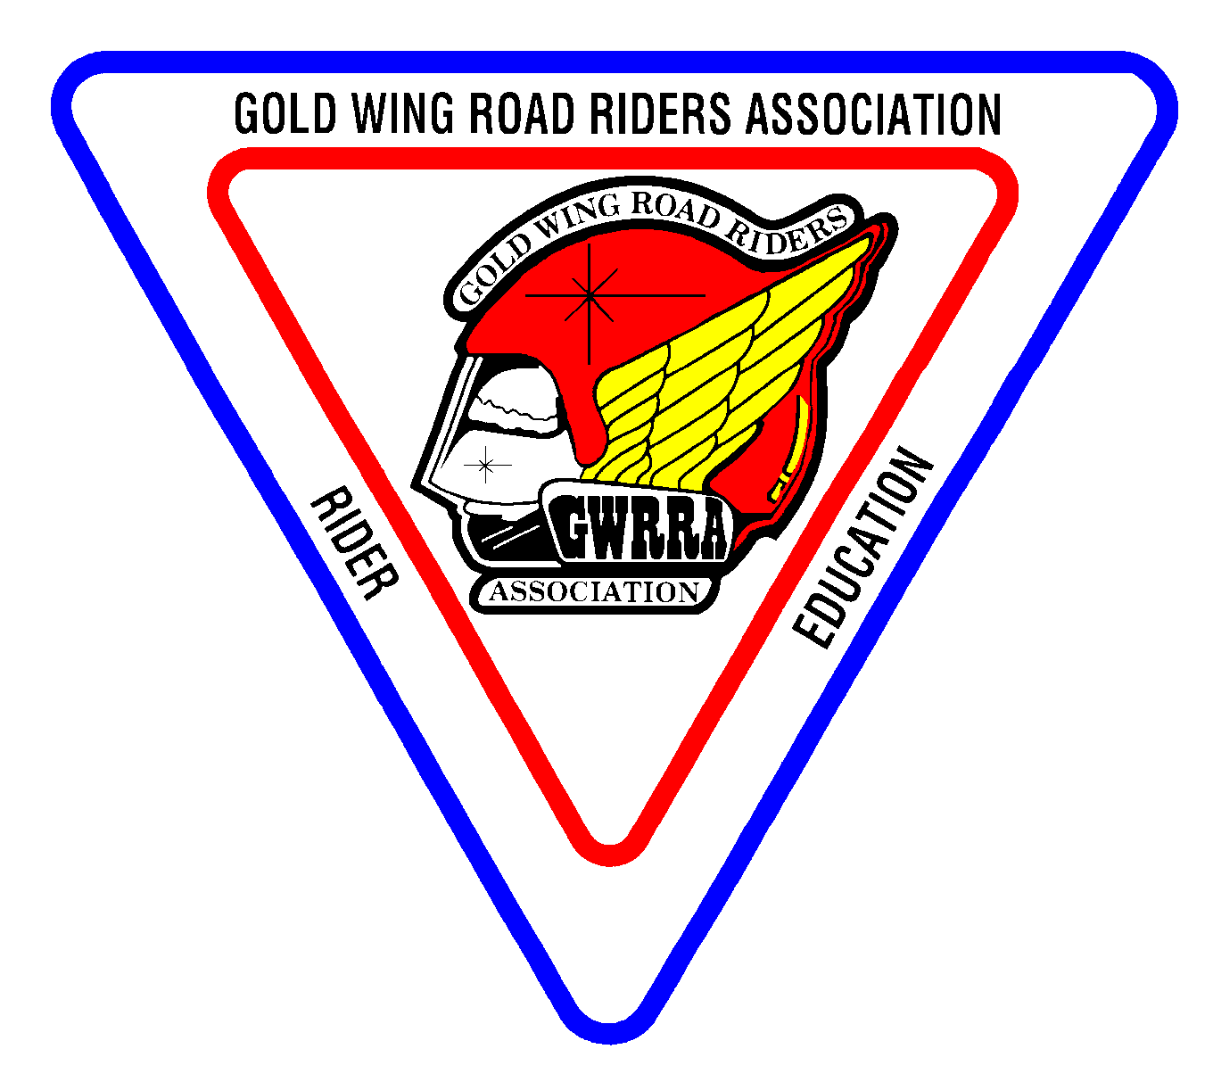
Don Blake can be contacted via e-mail to rideredfl1d@aol.com if desired.


Need a Chapter shirt, cap or flag? See Sonny at the February meeting or call him at 562-4293.

Forever A Goldwinger

Written & Dedicated By Todd A. Clark
from Region A web site
http://www.gwrra-regiona.org/RAHome.htm

Those days that I cruise down the road on my Gold Wing,
Are the special days in my life where my heart soars and sings-
To that of the melody of my heart racing that makes me come alive again,
For I'm never to old, nor to young to those places where I have been-

The highways are like pathways to the Winger's delight,
As riding past cars they wave and tell us we're outta sight-
I weigh not or dare to measure the distance I have traveled,
Nor the time in hours, minutes even days that I have spent on my rides-
For to those of us who are Goldwingers we take great pride,
As we ride to the great west-
Knowing that we own the road and we know we're the best,

Or perhaps to the east-
It's no joke or even a tease,
For when we head south-
We see people just drop their mouths,
Then as we head back home to the north-
We say ah hell, let's do it again for what it's all worth,

Now this goes without saying that we could have been many things in life-
Perhaps a doctor, teacher or preacher,
But hey, I'd rather just continue being one heck of a Goldwinger!!!


Corner
by Karen E. Krebs

AMA Liaison http://www.ama-cycle.org/

New Federal Rules Legalize Insurance Discrimination
American Motorcyclist Association Press Release # G01001

PICKERINGTON, Ohio -- Motorcyclists and others involved in recreational activities could be left without vital health-care coverage as a result of new regulations released by a group of federal agencies last week, reports the AMA. Ironically, the rules, written in response to federal legislation banning health-insurance discrimination, could end up having precisely the opposite effect.

The new regulations, issued jointly by three federal agencies, are the culmination of a rule making process that has dragged on for nearly five years since Congress passed the Health Insurance Portability and Accountability Act of 1996. And, the AMA notes, the final version of the regulations appears to directly contradict the will of Congress in passing that law.

The purpose of the original legislation was to protect workers from discrimination in the health insurance they receive through their employers. As written by Congress, the bill would have prohibited employers from denying health coverage based on a worker's pre-existing medical conditions or participation in legal recreational activities. The official language in the Congressional Record from that time noted that the law "is intended to ensure, among other things, that individuals are not excluded from health-care coverage due to their participation in activities such as motorcycling, snow mobiling, all-terrain vehicle riding, horseback riding, skiing and other similar activities."

AMA worked hard to get that language included in the Congressional Record after uncovering incidents where employers were discriminating against motorcyclists, leaving them without coverage anytime they were involved in recreational pursuits. AMA noted that the cases of discrimination it uncovered extended health-care protection to employees involved in illegal activities like driving a car while drunk, but cut them off from many legal activities.

Since the passage of the original bill, the AMA has repeatedly called on the federal agencies involved--the Internal Revenue Service, the Pension and
Welfare Benefits Administration, and the Health Care Finance Administration--to release the regulations that would govern enforcement of the law. The agencies delayed the process until the closing days of the Clinton administration, finally releasing regulations on January 5th.

The new regulations at first state that an employer cannot refuse health-care coverage to an employee on the basis of participation in recreational activities. But they go on to say that health-care benefits can be denied for injuries sustained in connection with those recreational activities. "To say that an employer can't deny health-care coverage to motorcyclists, but can deny coverage of any injury related to motorcycling makes this entire law meaningless," said Ed Moreland, the AMA's vice president of government relations. "Instead of creating a law specifically ending health-care discrimination, as Congress intended, these agencies have legalized discrimination."

"These rules open the door to the elimination of health coverage for all types of legal recreational activities, from motorcycle riding to running or walking. That's the exact opposite of what Congress had in mind."

The AMA is urging all motorcyclists--and those involved in any other type of recreational activity--to protest these regulations during a public-comment period that remains open through April 9. However, the AMA notes that by the time comments are sent in, the new Bush administration will be taking charge in Washington, meaning that different officials may be in charge at these agencies. "We believe that the change of administrations in Washington gives us a chance to appeal this arbitrary set of regulations," said Moreland. "We are in a position to ask new administrators to undo the mistakes of their predecessors."

Comments can be sent to the following three agencies. Comments sent by regular mail should include a signed original and three copies. E-mail comments do not require multiple copies.

Internal Revenue Service
P. O. Box 7604, Ben Franklin Station
Washington, DC 20044
www.irs.gov/tax_regs/regslist.html
Health Care Financing Administration
Department of Health and Human Services
Attention: HCFA-2022-IFC
P. O. Box 26688
Baltimore, MD 21207
U.S. Department of Labor
Pension & Welfare Benefits Admin.
200 Constitution Ave. NW, Room C-5331
Washington, DC 20210
Attn.: Non-discrimination Comments
HIPAA702@pwba.dol.gov



Swap Shop
Free to Chapter FL1-A2 members
call 925-0345

FOR SALE: Call Steve Carroll (850) 907-0776 evenings or (850) 942-9650 ext. 3004 days
Markland Black/Charcoal backrest ($179 retail) $95.00
Markland Black/Charcoal extended armrests ($119 retail) $75.00

FOR SALE: Call Charles Couch 562-1399.
One piece insulated riding suit, size Large (short). Like new, $50.
Small HJC FJ8 helmet, candy apple red open face w/ flip shield, $50 (Cost $124.99 on the web).

FOR SALE: Call Sonny Rollo 562-4293.
1982 Gold Wing, 20,000 miles, damaged in front end collision. No front wheel or fork. Engine, frame, instruments, rear suspension and wheel in good condition. $700 or best offer.
Kuryakyn triple exhaust extensions; used, very good condition for GL1500 $60.
Stop and Go tire patch kit - new $30.
Chrome windshield trim with Kuryakyn lighted bird and bug deflector, installed $65.
Orville Sage custom windshield for GL1500, tinted with large engraved eagle, with engraved wind wings, installed $175.

FOR SALE: Call Curtis Parker (229) 377-3260
DOWCO Guardian bike cover (G45 - small) - new, never out of the box! $35. GL1500 trunk handle, chrome w/hand insert, $20.
Women and Motorcycling Exhibit
submitted by Tom Fisher

"Women and Motorcycling" is the theme of a new traveling exhibit that is part of the Cycle World International Motorcycle Show sponsored by Toyota Trucks. The show will be in Atlanta February 16-18 and in Daytona March 7-11.

The exhibit was created by the AMA working with the Motorcycle Hall of Fame Museum from Pickerington, Ohio. Women have been riding motorcycles for a long time, but, as with women pilots, they did not get much recognition. Previous to the end of World War II, motorcycles did not have the same "negative" reputation they have had in some circles. It was not uncommon for women to be a skilled in riding bikes as the men. One woman featured in the exhibit began her riding career at age 16. She completed several cross country trips and ended up being a dispatch rider for the Army.

If any of you get to Ohio to see the museum or to Daytona to see the exhibit, please write an article about it for the newsletter!

More information can be found at the AMA website www.amadirectlink.com. Or, you can look at the February/March issue of American Heritage magazine.

Don't forget to sign up your
co-rider!
LOCAL RALLIES & EVENTS
February 8 Chapter meeting - Western Sizzlin'
Departure Points
#1: Hardees, N. Monroe
#2: Circle K, Hwy. 20 & Capital Circle
#3: Circle K, Crawfordville Hwy. & Capital Circle
#4: Chevron, Hwy. 98 & Woodville Hwy.
#5: CITGO, Hwy. 90 & I-10 east
#6: Books-A-Million,
Thomasville Road & I-10
#7 River Trace Homes, Woodville Hwy. & Capital Circle SE
#8 I-10 rest stop west of Exit 28 (Capital Circle NW)
6:30 eat, 7:30 meet
February 15 Dinner ride - Bay's Seafood, Sneads.
Departure Points
#1: Hardees, N. Monroe
#2: Circle K, Highway 20 &
Capital Circle
#3: Circle K, Crawfordville
Highway & Capital Circle
#4: Chevron, Highway 98 &
Woodville Highway
#5: CITGO, Hwy. 90 & I-10 east
(cross creek)
#6: NEW Publix, Thomasville
& Bradfordville Road
#7 I-10 rest stop west of Exit 28
(Capital Circle NW)
Depart #7 at 6:30 pm.
February 17 Grand opening, Lake City Honda. Depart
#5 at 9:00 a.m.
February 22 Dinner Social - Olive Garden, Apalachee
Pkwy. Eat at 6:30 p.m.
February 24 6 chapter breakfast - 11:30 cst, Mike's Diner,
Panama City Beach (Front Beach Road, 98A).
Depart #2, 9:30 a.m. est
March 15 Chapter meeting - Western Sizzlin' - 6:30 eat,
7:30 meet.
March 22 Dinner ride-The Oaks, Panacea. Depart at 6:30
March 29 Dinner social - Ming Tree, Crawfordville
Hwy., south of Crawfordville. Eat at 6:30 pm.
April 21 Chapter Camp out - Pat Thomas Park, south of
Quincy. Camping reservations - 875-4544. Camping $10.70 per night - must send check in advance to Pat Thomas Park, 949 Hopkins Landing Road, Quincy, FL 32351.
August 4 Chapter Bike Show - Tallahassee Mall
September 29 Chapter Camp out - Holiday RV Park, Panacea.
Camping reservations - 984-5757. The Oaks Motel - 984-5370.
February 16, 2002 Chapter rally

REGIONAL RALLIES & EVENTS
February 24 FL1-K - Leesburg
March 2 - 11 Region "A" Gold Wing Getaway, New Smyrna Airport
March 29 - 31 Florida Wing Gathering - Tampa
April 19-21 Alabama District Rally, Muscle Shoals, AL
May 3-5 S. Carolina District Rally, Greenville, SC
May 12 FL1-Y - Waldo
May 26 FL1-F2- Ocala
June 2 AL-G - Samson
June 14 - 16 Georgia Wing Fling - Hiawassee
June 20 - 23 Honda Hoot - Knoxville, TN
Wear Your Colors

Don't forget to wear your Chapter uniform at other chapter's events! Our
uniform is the red Chapter shirt and black jeans.
July 3 - 6 Wing Ding - Greenville, SC
July 28 FL1-D - Pensacola
Sept 6-8 Region "A" Rally - Helen GA
September 20 -22 NC District Rally - Fletcher, NC
October 6 FL1-L - Panama City
October 11 - 13 Mississippi District Rally, Biloxi
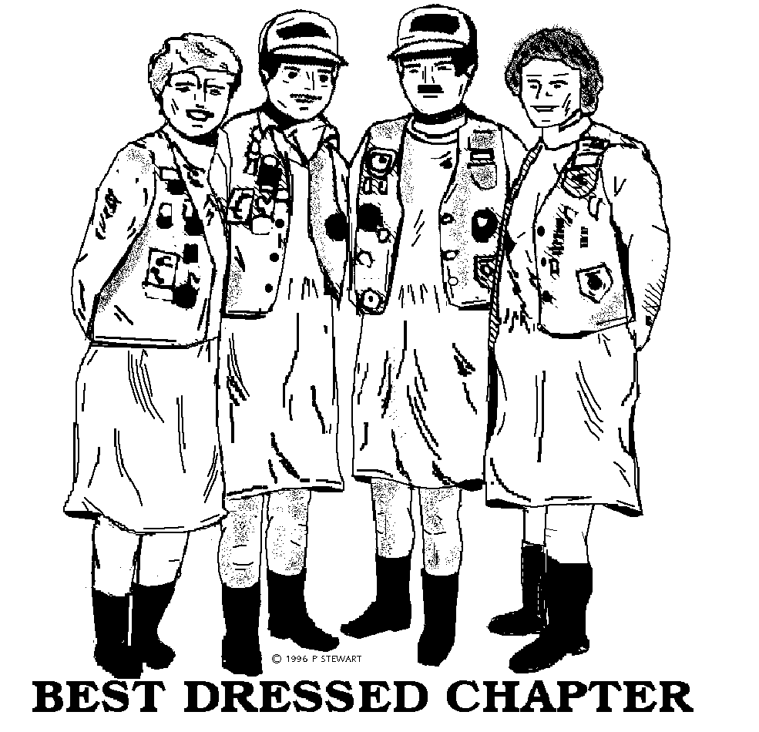
October 13 FL1-L2 - Bike Show, Lutz
Departure Points
#1: Hardees, N. Monroe
#2: Circle K, Hwy. 20 & Capital Circle
#3: Circle K, Crawfordville Hwy. & Capital Circle
#4: Chevron, Hwy. 98 & Woodville Hwy.
#5: CITGO, Hwy. 90 & I-10 east
#6: Books-A-Million,
Thomasville Road & I-10
#7 River Trace Homes, Woodville Hwy. & Capital Circle SE
#8 I-10 rest stop west of Exit 28 (Capital Circle NW)
October 18 - 21 Biketoberfest - Daytona
October 26 - 27 Sweet Potato Festival - Ocilla, GA
November 3 FL1-J - Jacksonville
November 24 FL1-A - Tampa
December 8 FL1-S - Zephyrhills
Many flyers available at the meeting from Charles Couch or Hugh Waller. Call Charles or the Telephone Coordinators for more information on scheduled and unscheduled rides!

