
GWRRA Chapter FL1-A2, established 1982 December 2000
NATIONAL OFFICE Mike & Judy Wright, Executive Director (219) 248-8166
REGION A DIRECTOR Jim & Margie Hodge (228) 875-1764
DISTRICT DIRECTOR Bob & Nancy Shrader (813) 885-7963

CD Gold Line

Thanks To A Great Team!
This week I notified Florida District Director Bob Shrader that I was stepping down as Chapter Director. I have enjoyed the challenge and wish my successor the best. I would like to especially thank my staff who are the greatest: Wayne Parmer and Rick Stanley my Assistants; Kate Smith, Treasurer; Carolyn Campbell, Sunshine Committee; Charles Couch and Sonny Rollo, Ride Coordinators; Tom Fisher, Public Relations, and last but not least, Karen Krebs, our Newsletter Editor and door prize collector. It takes a team effort to run a chapter and we definitely have a great team! Thank you from the bottom of my heart for your support.

As you all know, I wrecked my motorcycle October21st. I carried Progressive Insurance on my bike. I have had some bad experiences with insurance companies in the past. I can't say enough positive things about the service I have received from Progressive. The staff has gone out of their way to make sure my medical treatment is handled and paid promptly. They call me every week to see how I am doing and to recommend proper treatment. Also, as soon as I sent in the estimate on the repairs on my bike in a very few days I had the check in my hands to pay for the repairs. Needless to say, I am a very satisfied customer of progressive insurance company! (Editor's Note: I had the same service from GEICO when the 84-year old lady creamed my bike. Florida Motorsports had a check a week after the accident!

Ann and I would also like to wish all of our members a happy holiday season and we hope you find the time to take many rides in the coming year.

Ride safe and ride often,

John & Ann
Chapter Director

CHAPTER DIRECTOR
John & Ann Bartlow
(850) 421-1397

ASST. CHAPTER DIR.
Wayne Parmer 926-5371
Rick Stanley (850) 656-6609

SECRETARY/TREAS.
Kate Smith (850) 926-1608

RIDE COORDINATOR
Charles Couch 562-1399

RIDER EDUCATOR
Vacant

NEWSLETTER EDITOR
& AMA COORDINATOR
Karen Krebs (850) 925-0345
krebsk@freenet.tlh.fl.us

PUBLIC RELATIONS
Tom Fisher (850) 386-8493

PHONE COORDINATORS
Charles Couch 562-1399
Sonny Rollo (850) 562-4293
Karen Krebs krebsk@freenet.tlh.fl.us

SUNSHINE
Carolyn Campbell
(850) 997-4901

Positions available: contact John to get involved!

GWRRA NEWS
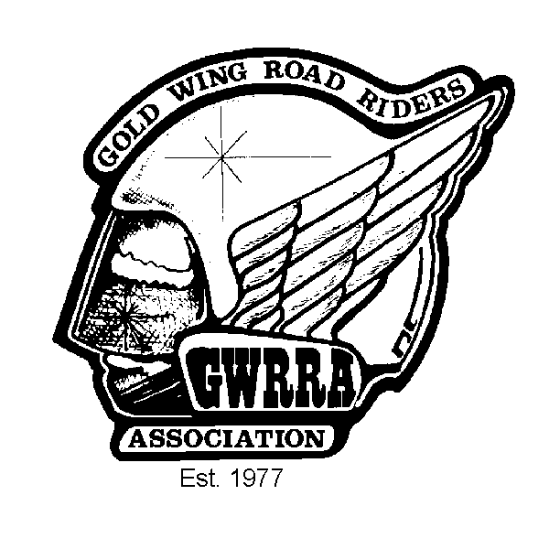
The Chapter Must Go On!
By Bob Shrader
Florida District Director

Members of Chapter FL1-A2, Nan and I were sorry to learn of John Bartlow’s intention to resign as Chapter Director effective December 31st. John’s services are greatly appreciated. We always hope that Officers stepping down will remain active with their chapters, and of course this is the case with John. It takes a lot of personal commitment and dedication to hold the job of Chapter Director and John certainly was not lacking in either. He will be missed.

The Chapter must go on, however and we are very fortunate that an “Old Soldier” with FL1-A2 has agreed to step in and keep things running on an interim basis. That person is former Senior Chapter Director, Charles Couch. Charles answered the call to service when we needed him and we are thankful for agreeing to resume the duties of Chapter Director when his chapter needed him. Charles has agreed to remain on for several months while he looks for a successor. Charles has already spent many years in this post and needs YOUR help in finding someone who will take the job on a long-term basis. Please give serious consideration when Charles asks you to assist in some chapter post. He can not and should not be expected to do it alone. The Canopy Road Cruisers has a long history of being an active and well-known chapter throughout the District. Please help Charles keep it that way.

Your Florida District staff is here to help you in any way we can. The Assistant District Director for your area is Jack Birge. Jack was a former Senior Chapter Director at FL1-O (Crestview) and knows the system well and knows what it takes to make a chapter successful. Jack and Charles will be working together to assemble a staff, so please help them (and FL1-A2) by agreeing to take an appointment.

Nan and I look forward to seeing you all in the near future!



Swap Shop
Free to Chapter FL1-A2 members
call 925-0345

FOR SALE: Call Charles Couch 562-1399.
One piece insulated riding suit, size Large (short). Like new, $50.
Small HJC FJ8 helmet, candy apple red open face w/ flip shield, $50 (Cost $124.99 on the web).
FOR SALE: Call Sonny Rollo 562-4293.
1982 Gold Wing, 20,000 miles, damaged in front end collision. No front wheel or fork. Engine, frame, instruments, rear suspension and wheel in good condition. $700 or best offer.
Kuryakyn triple exhaust extensions; used, very good condition for GL1500 $60.
Stop and Go tire patch kit - new $30.
Chrome windshield trim with Kuryakyn lighted bird and bug deflector, installed $65.
Orville Sage custom windshield for GL1500, tinted with large engraved eagle, with engraved wind wings, installed $175.
FOR SALE: Call Jack Schardine (904) 532-9602
Custom built cargo trailer. Convertible top, carpeted inside, spare tire, 48 quart cooler. $450
FOR SALE: Call Curtis Parker 422-0996.
DOWCO Guardian bike cover (G45 - small) - new, never out of the box! $35. GL1500 trunk handle, chrome w/hand insert, $20.

December Birthdays
Greg Campbell 12/2
Susan Van Gordon 12/4
Corinne Mathis 12/12
Tom Fisher 12/14
Mercy Henderson 12/18
Ben Hart 12/22
Charlie Parker 12/28

December Anniversaries
Steve & Sheila Carroll 12/17
Ben & Virginia Hart 12/19
Gary & B.J. Allen 12/21
Jerry & Ann Langley 12/22

Do you know a member with illness or death in their immediate family? Call Carolyn Campbell, Sunshine Chairperson, 997-4901.

WANT TO REACH OVER 80 MOTORCYCLE ENTHUSIASTS?
Advertise!!
Low rates: only $15.00 for a business card size ad for 3 months! Call the Advertising Department - (850) 925-0345 (ask for Karen) or
e-mail: krebsk@freenet.tlh.fl.us

BUSINESS CARD SIZE ADS
$15.00 for 3 mos./$50 per year
1/4 page $25.00 for 3 months
1/2 Page $35.00 for 3 months
Full Page $50.00 for 3 months
Next Month's Birthdays
Sheila Carroll 1/13
Donna Daniels 1/13
Rick Stanley 1/13
Gus Daniels 1/18
Steve Carroll 1/23
John Hancock 1/25

Next Month's Anniversaries
Frank & Faye King 1/8
Ray & Linda Henley 1/11

Time to Re-Up
from 1/00 printout
December
Richard Pulliam

"New Bike" Club
the newest "New Bike Club" member is Mike Share, proud owner of a 1997 Honda Shadow Spirit! He (and Karen) are all smiles!

Get the Lead Out Award
goes to Kate Smith for her story on the Sweet Potato Festival!!

GET THE LEAD OUT AWARD

is waiting for you!
Got an article? Call the editorial office:

(850) 925-0345
or e-mail: krebsk@freenet.tlh.fl.us

Articles may be submitted in WORD '97
or other convertible format.

Editor's Corner
by Karen E. Krebs

Thanks for Your Service, John!

As you read in the CD Gold Line, John has decided to resign. We thank him for all he has done for the Chapter, and for stepping up to the job when no one else would. Thanks John and Ann!

Thanks also to Charles for filling in temporarily. There is one thing that makes a successful chapter - PARTICIPATION! And not just going to rides and parties. Any organization takes w*rk (4-letter word censored for family newsletter). Events have to be planned, organized, etc.

We need people to step up to the plate as officers and staff. Are you willing to make a commitment to your Chapter? If you are interested in serving, contact Charles at 562-1399 or honda@nettally.com.


Corner
by Karen E. Krebs

AMA Liaison http://www.ama-cycle.org/

Biketoberfest Deaths May Bring Back Helmet Law

After losing the legislative fight this year to stop the helmet law repeal, the Florida insurance industry is renewing a call to force bikers to strap on helmets following the deaths of five people during Biketoberfest in Daytona Beach this past October.

Rep. Tom Feeney, R-Oviedo, who is expected to be the next House speaker, said he may introduce a bill in 2002. Tinkering with the law would only be likely if there are statistically significant increases in fatalities and injuries from motorcycle crashes, he said.

Ride safe!!!

Did You Miss the Sweet Potato Fest?
By Kate Smith

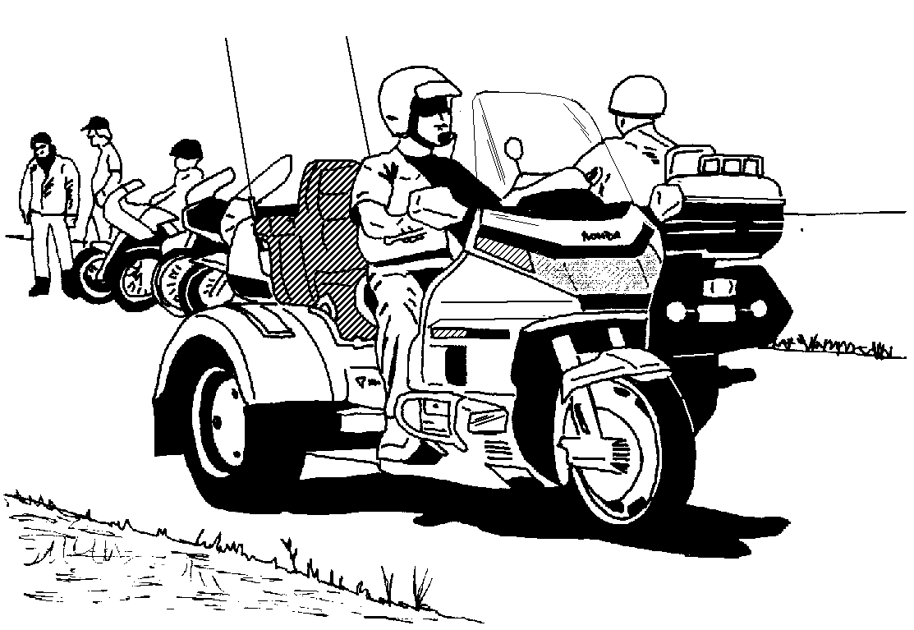
Ocilla was WONDERFUL. I think the whole chapter was there, except for John and Anne of course. I heard someone say there was over 1,000 bikes in the parade. Only 1 pink trike, though. 1600 people attended. Wouldn't it be great to have a rally like that! I met some new friends and friends I'd met there last year.

It was my first official attempt at camping. I'm not sure yet -- jury is still out. It was fun, but that sleeping on the ground stuff is a little low for me -- not to mention lumpy.
The food was great, entertainment was good especially Saturday night. I missed the 50/50 by 3 numbers. RATS. We saw Sunny Andrews for the first time in a long time. She sends her love. She's so busy teaching, this is the first break she's had in a LONG time. Her new trike is a beauty. We set up camp next to Ray Henley and didn't even know it until after supper Friday night.

What a trip! I rode all the way. Bud trailered his and our friend Hap's trike. Can't wait for next year!

Florida District Rally 2001
From the Florida District home page: http://members.spree.com/sports/fldistrict/

Date: March 28-31, it is one week later than normal but was moved to get better rates. Place: Radisson Hotel at Sabal Park, Hillsborough County, the hotel is conveniently located at the intersection of I-75 and SR 574. There is space inside the hotel for registration, games, Rider Education and a hospitality area. The closing ceremonies will be in the hotel ball room.
Reservation numbers: (813) 623-6363 or call (800) 333-333, rates for this outstanding facility are $75.00 per night for the Rally. The rooms all have balconies, refrigerators and coffee makers. They have been newly renovated. See the pictures of the hotel on the Florida District home page; I am sure you will agree the price is good for what we are getting. See the home page for a copy of the Rally registration to print out and mail in.
Vendors: The vendors will be located in the hotel parking lot (as it was at Kissimmee).
Directions: I-75 (South of I-4) Exit 52 (SR 574) Tampa, Florida
Flyers: They are out, please consider pre-registering and encouraging your friends to do the same.

"Surperbikes of Miami" Shows Their Support (and generosity) Again!

Check out the new Florida District "For Sale" page!
http://members.spree.com/sports/fldonline/

LOCAL RALLIES & EVENTS

December 14 Chapter meeting - Western Sizzlin'
Departure Points
#1: Hardees, N. Monroe
#2: Circle K, Hwy. 20 & Capital Circle
#3: Circle K, Crawfordville Hwy. & Capital Circle
#4: Chevron, Hwy. 98 & Woodville Hwy.
#5: CITGO, Hwy. 90 & I-10 east
#6: Books-A-Million,
Thomasville Road & I-10
#7 River Trace Homes, Woodville Hwy. & Capital Circle SE
#8 I-10 rest stop west of Exit 28 (Capital Circle NW)
Departure Points
#1: Hardees, N. Monroe
#2: Circle K, Highway 20 &
Capital Circle
#3: Circle K, Crawfordville
Highway & Capital Circle
#4: Chevron, Highway 98 &
Woodville Highway
#5: CITGO, Hwy. 90 & I-10 east
(cross creek)
#6: Books-A-Million,
Thomasville Road & I-10
#7 I-10 rest stop west of Exit 28
(Capital Circle NW)
6:30 eat, 7:30 meet
December 16 Christmas party and bonfire at Bud & Kate
Smith's, 6:00 p.m.
January 11 Chapter meeting - Western Sizzlin'
6:30 eat, 7:30 meet
January 18 Dinner ride - Farmer's Market, Thomasville.
Depart #6 at 6:30 pm.
January 25 Dinner Social - TBA
February 8 Chapter meeting - Western Sizzlin'
6:30 eat, 7:30 meet
February 15 Dinner ride - Bay's Seafood, Sneads.
Depart #7 at 6:30 pm.
February 22 Dinner Social - TBA

REGIONAL RALLIES & EVENTS

March 2 - 11 Region "A" Gold Wing Getaway,
New Smyrna Airport
March 29 - 31 Florida District Rally - Tampa
April 19-21 Alabama District Rally, Muscle
Shoals, AL
May 3-5 S. Carolina District Rally,
Greenville, SC
July 3 - 6 Wing Ding - Greenville, SC
Sept 6-8 Region "A" Rally, Helen GA

Don't forget to
sign up your
co-rider!
Departure Points
#1: Hardees, N. Monroe
#2: Circle K, Hwy. 20 & Capital Circle
#3: Circle K, Crawfordville Hwy. & Capital Circle
#4: Chevron, Hwy. 98 & Woodville Hwy.
#5: CITGO, Hwy. 90 & I-10 east
#6: Books-A-Million,
Thomasville Road & I-10
#7 River Trace Homes, Woodville Hwy. & Capital Circle SE
#8 I-10 rest stop west of Exit 28 (Capital Circle NW)
Wear Your Colors

Don't forget to wear your Chapter uniform at other chapter's events! Our
uniform is the red Chapter shirt and black jeans.
NEWSLETTER DEADLINE: 4th THURSDAY
PUBLICATION: 2nd THURSDAY
Please let us know if you no longer want a newsletter - they cost us $1.02 each!!!

Many flyers available at the meeting from John Bartlow. Call Charles Couch or the Telephone Coordinators for more information on scheduled and unscheduled rides!

